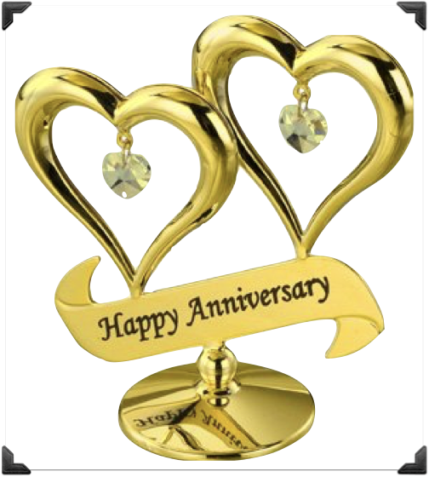

“thanks” for the memories

From your SIR Branch members

AG Lee Moy