Century Sir- 100 year

PreSidential award
HonorS

Member Name here

on acHieving a mileStone in life
aS a
Member of Branch name NO. XX

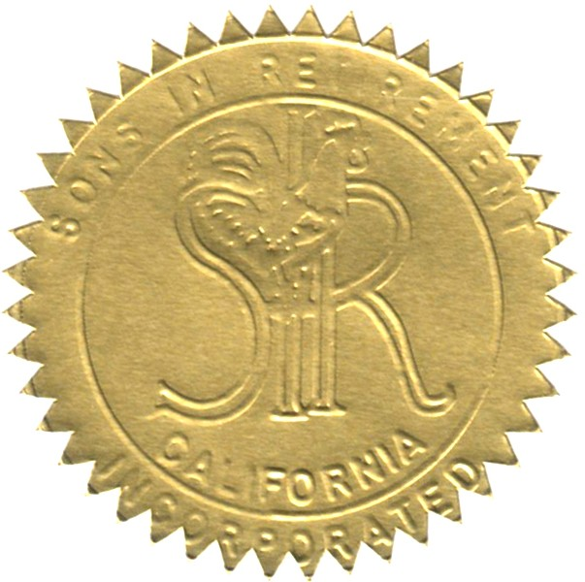
recognized by
Dale Decker
sir state president

1/10/2024
date

