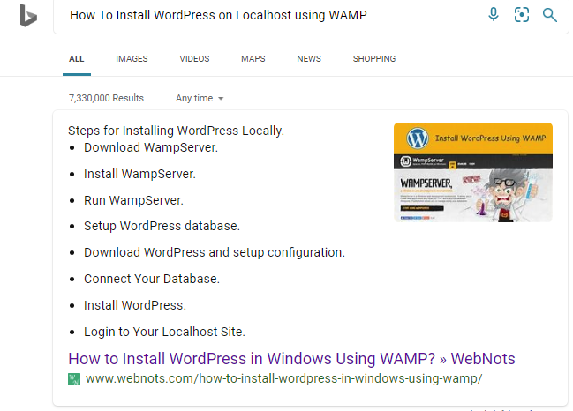

https://www.webnots.com/how-to-install-wordpress-in-windows-using-wamp/

